CSC 3210

Computer Organization and Programming

Lab 3 (b)

Answer Sheet

Student Name: Tracy Michaels

Section:

Debug through each line of code and explain the register content and flags.

(We already answered line 10 to 13 for your reference. Start writing your answer from Line 14)

Line: 10

Instruction: mov eax, 12345678h

Register value: EAX = 12345678

Explanation: 12345678 is a hexadecimal value which is 32-bit in binary. EAX register is also 32-bit.

Line 11:

Instruction: mov ax, 1122h

Register value: EAX = 12341122h

Explanation: 1122 is hexadecimal and it is 16-bit in binary. this mov instruction only updates AX (16 bit) register, a part of EAX register. That’s why you can see that the upper portion of EAX register is NOT updated.

Line 12:

Instruction: mov bl, al

Register value: EBX = _ _ _ _ _ _ 22

Explanation: AL register is 8-bit long. When you mov the content of al register (22) to BL register, it only updates the first 8-bit of the EBX register. The rest contains the garbage value.

Line 13:

Instruction: mov bl, ah

Register value: EBX = _ _ _ _ _ _ 11

Explanation: Ah register is 8-bit long. When you mov the content of AH register (11) to BL register, it only updates the first 8-bit of the EBX register. The rest contains the garbage value.

Line 14:

Instruction: mov al, 89h

What Register value of EAX register, after executing line 14.

* Register value: EAX = 12341189h

Explain the content of the EAX register.

* Explanation: move the hexadecimal number 89h, which is an 8-bit binary number into the lower part of the EAX register (AL or A Low) while the rest of the EAX register remains unchanged

Line 15:

Instruction: add al, 10h

What Register value of EAX, after executing line 15?

* Register Value: EAX = 12341199h

Do you see any change in flags?

* Sign Flag changed to a 1
* Zero Flag changed to a 0

Show the step of the hexadecimal addition.

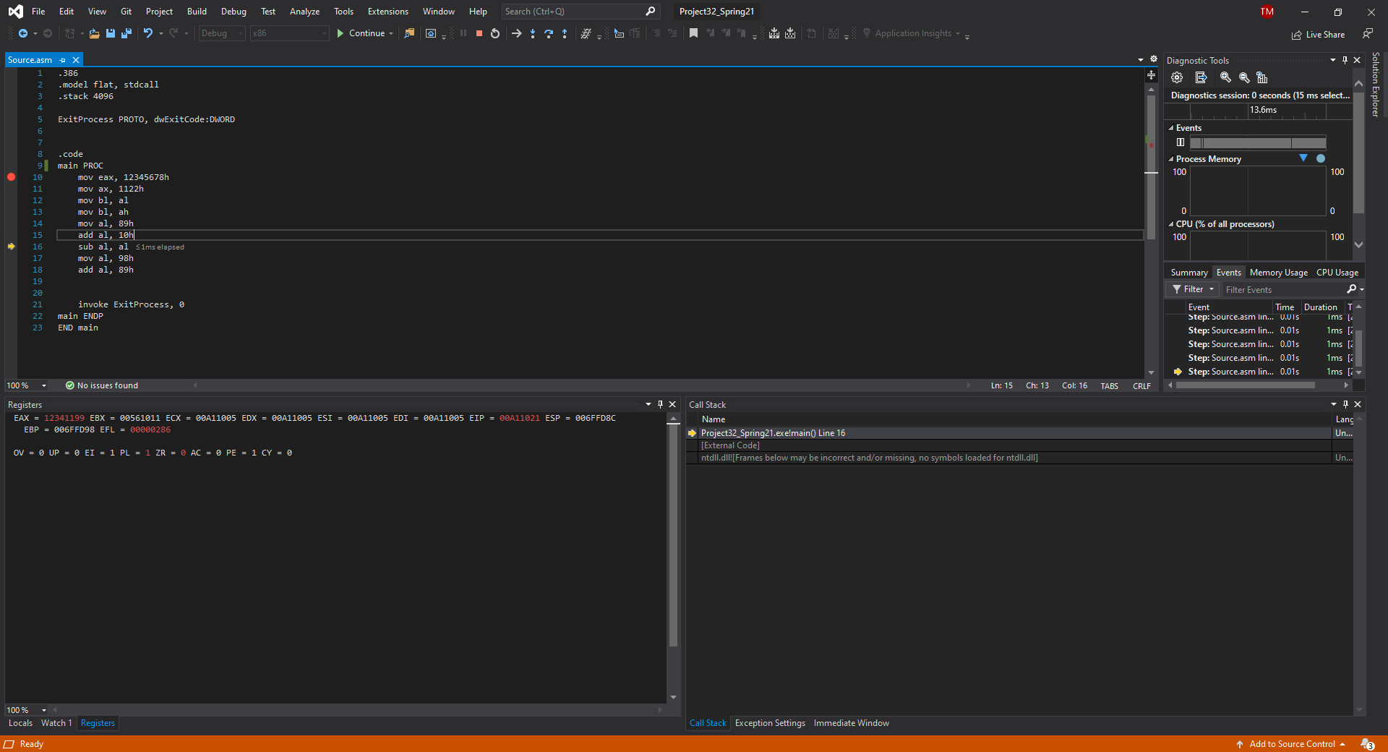

Line 16:

Instruction: sub al, al

What Register value of EAX, after executing line 15?

* Register Value: EAX = 12341100h

Do you see any change in flags?

* Sign Flag chanted to 0
* Sero Flag changed to 1

Show the step of the hexadecimal subtraction.

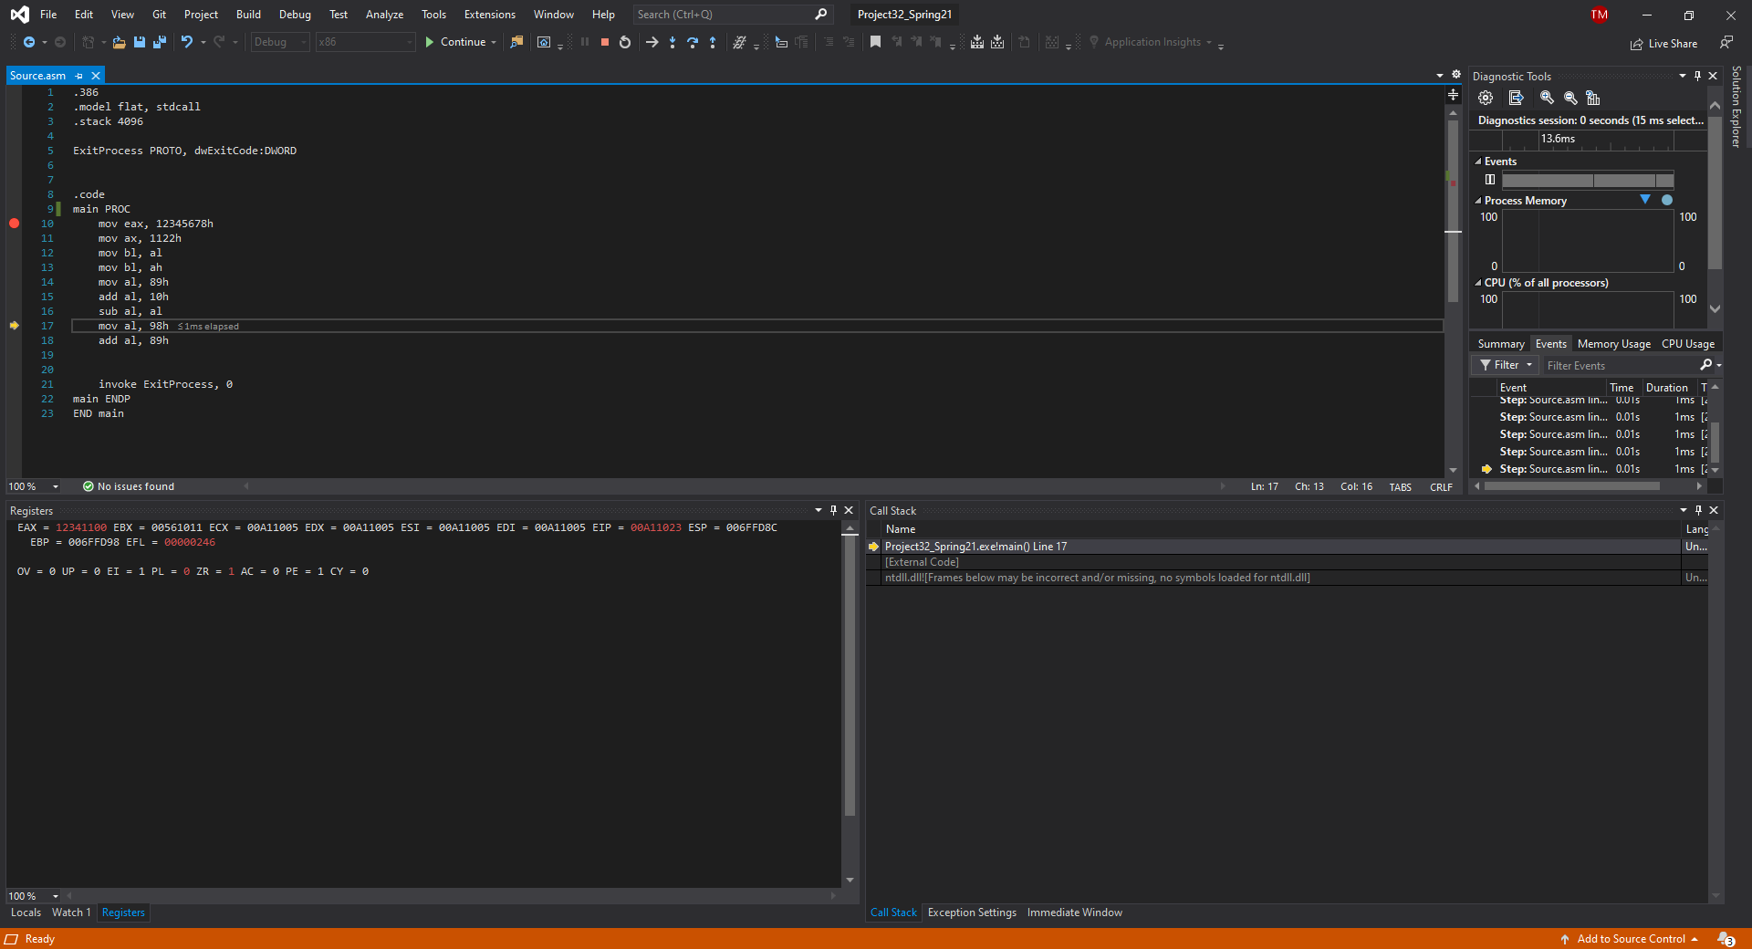

Line 17, 18:

Instruction:

mov al, 98h

add al, 89h

What Register value of EAX, after executing line 17 and 18?

* Line 17 Register Value: EAX = 12341198h
* Line 18 Register Value: EAX = 12341121h

Do you see any change in flags?

* Overflow Flag changed to a 1
* Zero Flag changed to a 0
* Carry Flag changed to a 1
* Auxiliary Flag Changed to a 1

Show the step of the hexadecimal addition.

